**Always label specimens at bedside using two (2) identifiers. Initial and write the time on all specimens.**

Specimen Container | Tests/Uses | Additional Info/Storage | Additive
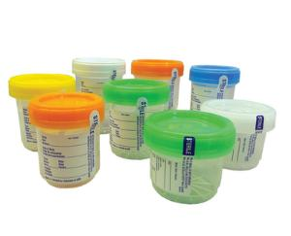  Urine Collection Cup | Random Urine Chemistries, Urine Osmolality ,  Urinalysis, Urine Drug Screen, Urine  Microalbumin | Storage: Refrigerate (up to 24 hours)  Must arrive at the lab within 24 hours of collection | None
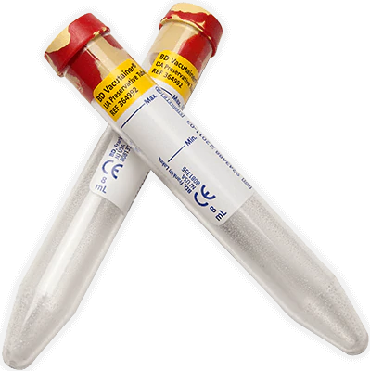  Cherry Red/Yellow Marble Top | Urinalysis | Minimum fill line is 7ml, Max fill line is 8ml  Storage: Refrigerate (up to 72 hours) | Chlorhexidine, Ethyl Paraben, Sodium Propionate
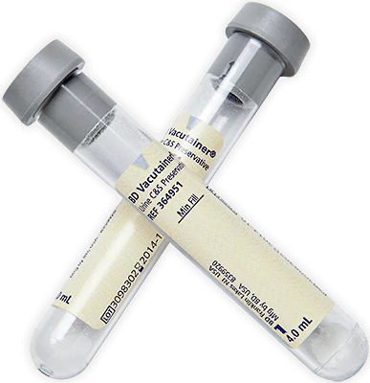  Grey Urine Culture Tube | Urine Culture & Sensitivity | Minimum fill line is 3ml.  Storage: Room Temperature (up to 72 hours) | Boric Acid, Sodium Formate, Sodium Borate
Sterile Specimen Container | C-diff (Stool) | Storage:Refrigerate immediately (up to 24 hours; freeze if test cannot be performed within 72 hours. | None
 | Occult Blood (Guiac) | Storage: Room temperature or Refrigerate (up to 72 hour) | None
 | Stool, sputum, tissue, body fluid, cath tips | Storage: Room temperature (up to 24 hours) | None
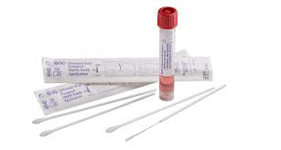  Viral Transport Media | Viral Cultures, COVID-19, Respiratory Panel | Storage: Room temperature;  transport to laboratory after  collection (up to 24 hours) | UTM-RT  Universal Transport Media
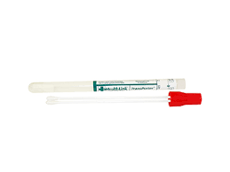  Red Culture Swab Collection | MRSA screen,  VRE/CRE screen, Throat Culture | Storage: Room Temperature  (Up to 72 Hours) | Red Top Culture Swab, Dual Applicator with liquid Stuart Sponge
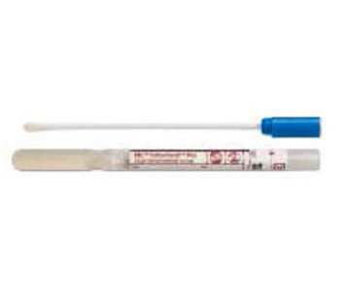  Blue Culture Swab Collection | Anaerobic, Aerobic & Routine Cultures, Fungal Cultures | Storage: Room Temperature  (Up to 72 Hours) | Blue Top Culture Swab w Aimes Gel
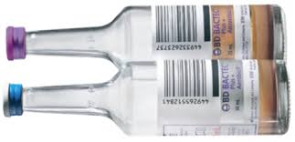  Blood Culture Collection | Blood Culture  Anaerobic & Aerobic Bottles  1 Anaerobic + 1 Aerobic bottle = 1 set | Storage: Room Temperature  (Up to 72 Hours)  Note: Must draw before routine orders, use sterile techniques. Monitor volume (need 5ml to 10ml of blood per bottle. Invert each bottle x10 to mix. | Media
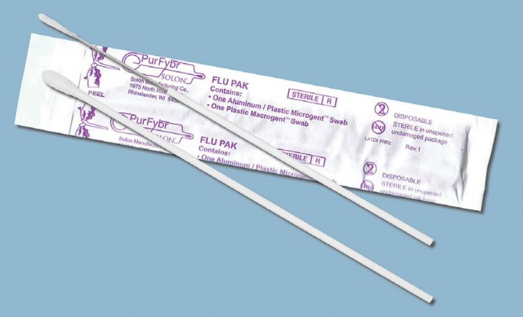  Flu Swab Collection | Flu Swab | Storage: Room temperature, must be picked up and brought to the lab ASAP | Nasal Flocked Swab
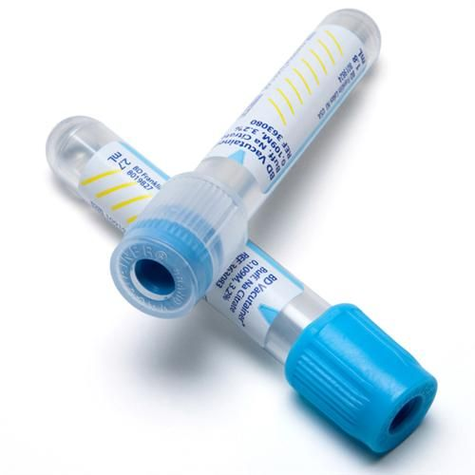  Blue Top Tube | PT, PTT, PT/INR, D-Dimer, Fibrogen, Platelets (If requested by the lab due to platelet clumping) | Must fill to proper level, gently invert x10. Note: When drawing with a butterfly needle, you must use a discard tube to remove air in tubing to fill your blue top tube to the proper level.  Storage: Refrigerate | Sodium Citrate
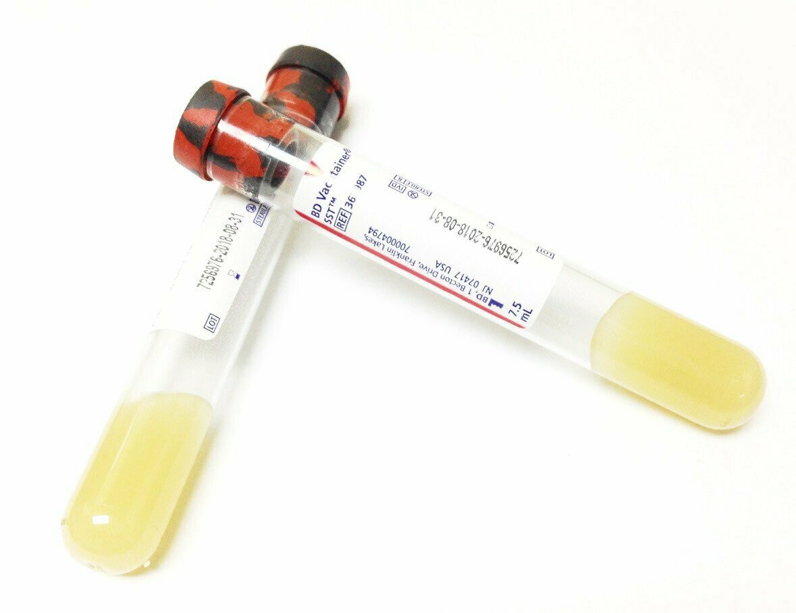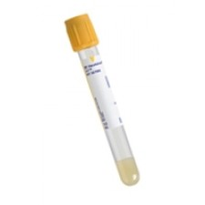  Serum Separator Tube SST/Gel/Tiger Top/Gold Top Tube | ALT, AST, Amylase, Albumin, B12, BMP/CMP, Cardiac Panel, Ionized Calcium, Calcium, CRP, Hepatitis, HIV, Iron, Lipase, Lipid, LFT, Renal, Lytes, Prealbumin, PSA, RPR, Uric, TSH, T3, T4, Pro-BNP | Storage: Refrigerate after centrifuging. Centrifugation: After allowing the clot to form (15 to 30 min), Centrifuge for 10 min. | Serum Separator/Gel
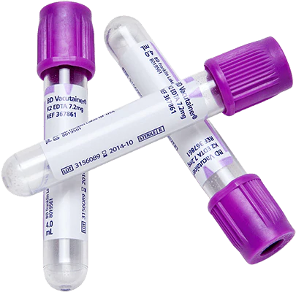  Lavender Top Tube | BNP, CBC, H&H, HgbA1c, Platelet, PTH Intact, Prograf, Retic, RBC Folate (Draw 2), ESR, Ammonia | Invert gently x10  Storage: Refrigerate  Ammonia: Place on ice immediately, STAT Delivery | EDTA
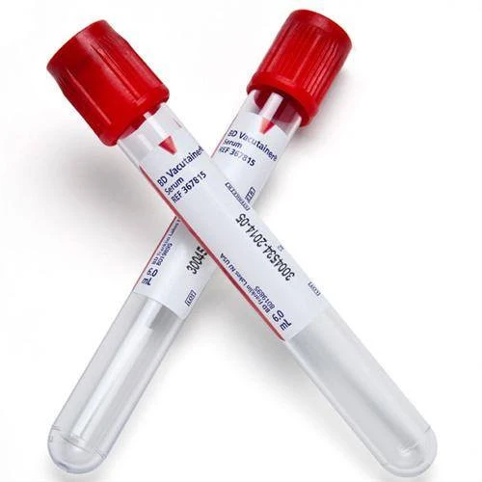  Red Top Tube | Drug Levels (Keppra, Dig, Dilantin/Phenytoin, Valproic Acid/Depakote, Vanco, Gent, Amikacin) | Storage: Room Temperature | None
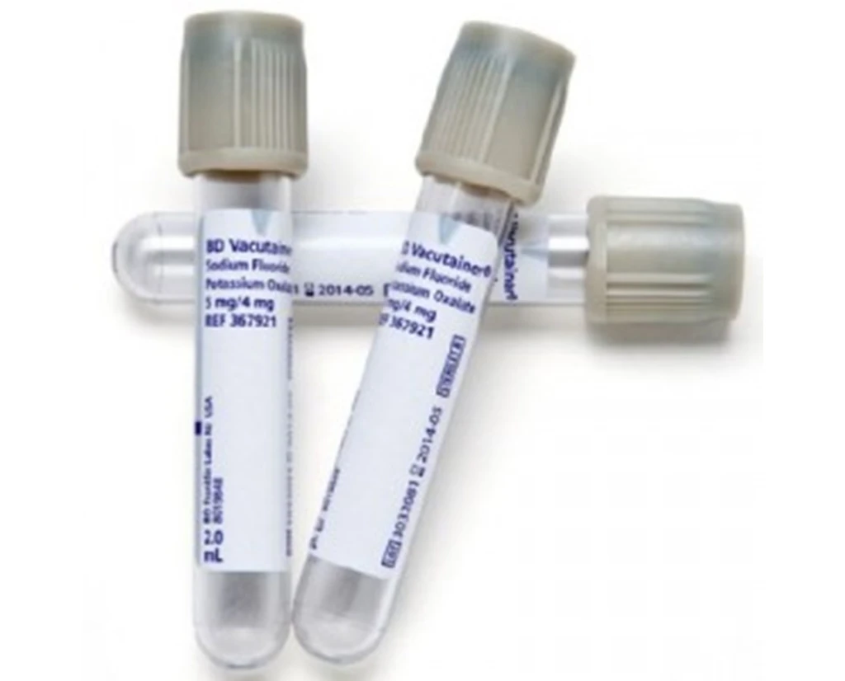  Grey Top Tube | Alcohol Level/ETOH, Glucose/FBS, Lactic Acid | Invert gently x10  Storage: Lactic Acid-Place on ice immediately/STAT Delivery | Sodium Fluoride

